All Dog Rescue, P.O. Box 17343, Minneapolis, MN 55417
www.alldogmn.org, alldogmn@yahoo.com
All Dog Speaks
In January, Shelley Cooksey joined the board of directors of All Dog Rescue as our interim Director of Finance. She was officially voted onto the board at our annual meeting this month. Shelley stepped into this role after our beloved Susan Bakken decided to step down from the board of directors to spend more time with her family. While Susan will no longer be on the board of directors, she will continue to foster and manage our website. We will miss Susan terribly but are very grateful to still have her as a volunteer. It must be said that without the talent and dedication of Susan, All Dog Rescue would never have been formed. With this in mind, All Dog Rescue sincerely thanks Susan for her many hours of service getting the group up and running. You can only imagine the amount of paperwork and miscellaneous tasks required to form a non-profit and Susan truly led us through this process and for that we are forever grateful.
For many of you Shelley will be a familiar face. Shelley is a long term foster and also served as our records coordinator since the start of All Dog Rescue. Shelley will continue fostering and managing our records but will now also be serving as our treasurer and as a board member, she will play an integral role in forming the future of All Dog Rescue. Shelley is tremendously talented and truly dedicated to our mission of finding life-long homes for rescued dog. She is a natural fit for this new challenge and we are all very excited to have Shelley taking on this new role. We hope you all will extend a warm welcome to Shelley.

Welcome Shelley Cooksey

All Dog Rescue T-Shirts are available!
If you have been looking for a way to show your support for All Dog Rescue we have just the item for you – your very own All Dog Rescue T-Shirt. The shirts are short sleeved but are the perfect weight for layering in the colder months so you will be able to wear your shirt all year long. The shirts cost $15.00 each and come in S, M, L, and XL and may be purchased on our website. At this time we only have women’s sizes but if you are interested in a shirt and would like a man’s size please e-mail us at alldogmn@yahoo.com.
Winter 2008
Volume 2, Issue 1
By Kathryn Schwartz

By Kathryn Schwartz

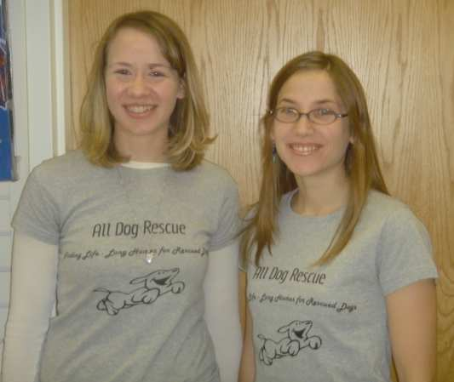

Maddie is one of our “special needs” dogs because she has allergies. She recently visited a dermatologist and we learned she is allergic to pollen and various kinds of dust. She is on a new treatment plan and is doing very well, but her forever family will need to commit to making sure Maddie remains comfortable year-round. Not a lot to ask in return for Maddie's love and loyalty.
Is your heart big enough for little Maddie to fit in it? If so, please visit our website at www.alldogmn.org
Maddie is a 3 year old, 23 pound girl who looks like a schnauzer/shih tzu mix. Maddie has been waiting a very long time to find a home of her own. She hopes that when you meet her you’ll understand she’s a little aloof but it doesn’t mean she won’t be your best friend if you give her a chance! While she is neutral at first, once she bonds to you she’s a friend for life and will follow you everywhere.
Maddie is laid back in the house, but she loves daily activity. She enjoys going to the dog park, where she plays chase with the other dogs. She also loves off-leash hiking where she will explore the woods but always keeps her foster mom within sight and comes immediately when called. But Maddie's favorite outdoor activity is fetch! She loves to chase tennis balls and will drop them at your feet and eagerly wait for you to throw the ball again.
Maddie is housetrained, and currently spends the work-day in a crate though enjoys sleeping freely on a dog bed at night. Her house manners are pretty good, though she will on occasion get into the trash or steal a sock out of the laundry and eat it before you know it's missing. But what's a dog without a little mischief?

All Dog Spotlight… Meet Maddie!

See you at the Expo!
All dog Rescue will be at the 2008 Twin Cities Pet Expo so please stop by our booth and say “hello”. The Pet Expo will take place on February 16th and 17th and we will be there on both days. This is a fun event where you will be able to see lots of dog related things so if you are looking for a new dog food or the perfect collar you just might find it at the Pet Expo!

Curing Winter Boredom
All year long your dog will need physical and mental stimulation to keep healthy. Keeping stimulated especially during the long winter months is
important to help reduce boredom, and burn off the excess energy form being cooped up inside the house. Unfortunately a lot of the store bought toys are expensive and may not last as long as hoped. Consequently, it can be really expensive to replace
toys over and over. Fortunately there are creative ways you can keep your canine entertained by making a few simple homemade dog toys.
Here are a few examples your pooch may appreciate.
1. If your dog enjoys fruits or vegetables you can cut up pieces and put them into the freezer. Apples, bananas, carrots seem to be particular favorites for dogs. These treats take longer to chew and are good antioxidants and vitamins. Remember, onions, grapes, and raisins are toxic to dogs so avoid these foods.
2. Another frozen treat toy is to mix peanut butter with kibble or plain yogurt with kibble then put it into a plastic cup enough to fill the bottom
1/3 of the cup. Place the cup into the freezer until frozen. This treat needs to be supervised closely if your dog is a chewer of plastic. Or if you have a store bought Kong this would work well instead of the cup.
3. Recycle on old cotton rope or an old pair of socks by tying several knots at each end to play tug-of war. This can also be a way to recycle an old pair of jeans. Just cut off the legs of the jeans and tie knots. Whenever you are using rope, make sure it is soft cotton not the synthetic ruff fiber. This is to help prevent cuts in their gums.
4. Toys can be made from tennis balls. You will need to drill a whole through it and out the other side. Then thread a cotton rope through the hole and tie the two ends of the rope to make a knot. Then challenge your friend to a game of tug of war or if the weather is nice outside you can toss the ball by swinging the rope to throw it.
5. Any scrape material such as fleece, jeans, corduroy or cotton can be cut into long strips braided and knotted at both ends to occupy your dog. If youwant to make the toy a little more functional, you could loop the ends of the fabric to give yourself a nice handle for a stronger hold. When using fleece, be sure the fabric has not been treated with a flame retardant.
As always supervise your pets to make sure they remain safe. Have fun!
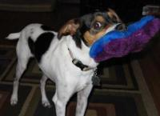
By Barb Williams


Bentley’s new mom passed on a note from Bentley we thought was worth sharing.
Dear All Dog Rescue:
Thanks so much for taking such good care of me until I found my "forever home". I've started to settle in (I've started giving my new mom kisses, and rolling over to ask for belly rubs), and my new mom seems pretty trainable: She knows that I like to sleep on the sofa, which toys and bones I like, and which dog parks are the best. Now if only I could train her to put away those gates that keep me out of the areas of the house reserved for the cats... I know they'd like me if they could spend more time with me! Just because I'm big and bouncy and roughly nine times their size doesn't mean we can't be friends; they just need more play time to convince them.
I still get to go to Downtown Dogs for daycare most days when Mom goes to work; once I figured out that she always comes back for me, I was OK with the idea. And it means that I get to see my pals - my friend Sandy (who gave me lots of cuddles when I was being fostered there) is really glad that she gets to keep getting my bear hugs! Mom says she figures that being there will help me burn off energy since I'm still just a pup, but I have her convinced that a

Happy Endings
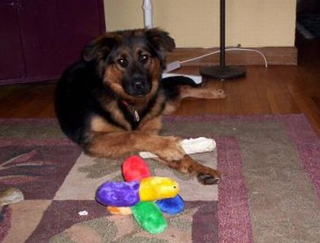
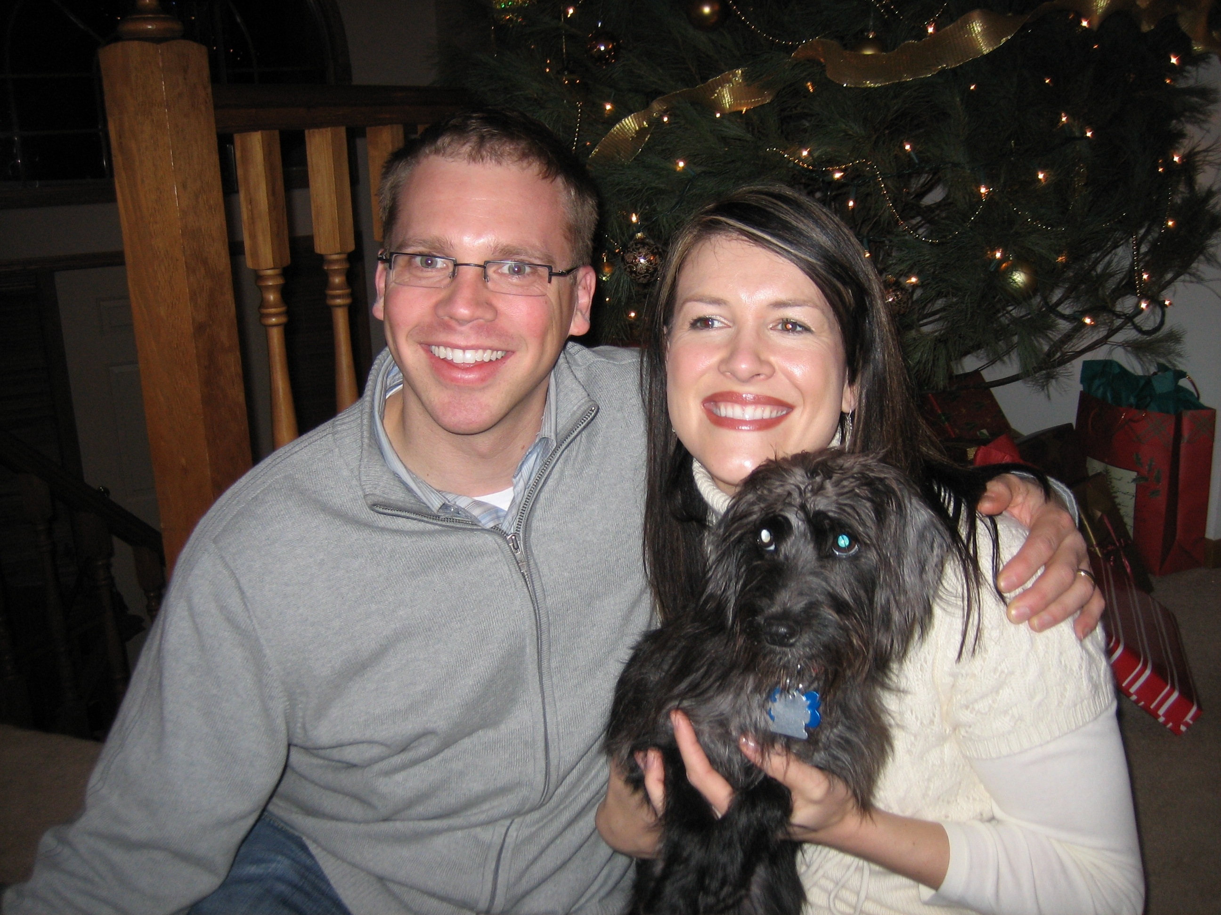

Little Lucy (fka Daisy) came to All Dog Rescue from a Metro area city impound. She arrived very straggly and in need of a good grooming. Under the loving care of her foster mom Linda, Lucy blossomed and was quickly adopted by her new family Hilary and Mark Cheeley. As you can see from the photo, Lucy is very loved by her new family. They write “Lucy (formerly Daisy) is doing REALLY well in her new home! Mark and I think she is the best dog we've ever laid eyes on since she is extremely cute and cuddly yet has tons of energy and loves to bounce around like popcorn when we go to the park. She is starting to learn her name and knows "sit" very well. Her favorite activities include curling up on the couch, licking Mark's face to wake him up, playing with her "sister" Holly (Hilary's mom and dad's Westie) when she comes to visit, and rolling over for anyone who will scratch her belly. Lucy's fur already seems glossier and I think the bare patches are already growing in. She's really an ideal dog and we are so thankful to have her!”

daily trip to the dog park afterward is a better guarantee that I'll stay out of mischief when we get home. If I'm tired enough, I don't even whine when I go in my kennel at night, which I now do on command, with a few motivational treats! (Sometimes when I hear the lid on the cookie jar I start to head that way!) Mom says that in a couple of weeks we'll start going to something called "obedience class"; that's probably a good thing - she could use a little more training, but I think she's smart enough to figure things out. Thanks again for taking such great care of me, and for helping me and my mom find each other!
Love,
Bentley

Aries came to All Dog Rescue from a shelter in Eau Claire Wisconsin. His foster mom Erica drove there and when she saw his sweet face she just could not leave him behind. Aries was adopted by a wonderful couple who take him to the Minnehaha dog park almost daily. They write: “Aries enjoys his new home!!!! He makes us laugh all the time with his goofy antics. He is always walking around with a stuffed animal in his mouth. Aries loves the fact that his moms bring him to the dog park and he has a chance to play with other dogs.” His moms have remained in touch with All Dog Rescue and frequently stop by our adoption events which we all enjoy. If you happen to frequent the Minnehaha dog park you just might see Aries. Just look for the Rottweiler mix with the silly beard!

Happy Endings Continued…
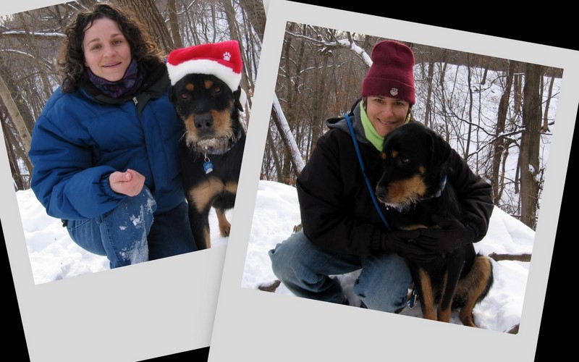

Kids and Dogs
By Barb Williams
Is there anything more adorable than watching a puppy and a child playing innocently together? For both it can be a wonderful bonding experience. It is also a great opportunity to learn the social boundaries they will both need to learn to live safely together. The children as well as the dog will need to have behavior training.
Obedience classes and socialization are important for any puppy or dog that will be
will be in contact with children. For example: puppies need to be taught early on that play biting on humans is not acceptable. Neither is jumping on people. Likewise children should be trained how to respect the differences between canines and humans.
Likewise children should be trained
how to respect the differences between canines and humans. Children need to
be taught not to play fight, yell or pull on a dog. Kids should know that
dogs have instincts that occur naturally. Some of these instincts are
chasing, herding, catching and or fetching. This means that running and
playing in the yard may be an instinctual invitation for a dog to chase
a child and perhaps jump on them. The dog may even try to fetch and play
catch with your childs toys and balls.
Another natural instinct for a dog is to protect things they care about.
It could involve food, or a favorite toy. Dogs may
also protect spaces,like eating, resting or sleeping spots. Another natural
response is when dogs protect the yard or home where they live.
Kids should always be supervised around dogs and learn to always ask dog
owners if it would be o.k. to touch or pet their dog.
Never let a child reach through a fence to touch a dog or help himself
into a home with a dog where there is no adult supervision.
Unfortunately, children under the age of 10 years old are at the highest
risk
to dog bites and injury. Most dog bites occur during play with a dog
the kids already know. A dog that is excited or nervous can even bite by
mistake.
So while most dogs are safe reliable family pets, even the most friendly dog
can become aggressive if threatened, hurt or sick. Generally most dogs that
are raised with children show no significant behavior problems. However, if
your pet has never been socialized or had experience with "little people"
supervising the interaction closely is a must.
While no prevention program is 100% successful, teaching the dog and the
children how to navigate different situations will give greater confidence
and safety to all involved.
Children need to be taught not to play fight, yell or pull on a dog. Kids should know that dogs have instincts that occur naturally. Some of these instincts are chasing, herding, catching and or fetching. This means that running and playing in the yard may be an instinctual invitation for a dog to chase a child and perhaps jump on them. The dog may even try to fetch and play catch with your child’s toys and balls.
Another natural instinct for a dog is to protect things they care about. It could involve food, or a favorite toy. Dogs may also protect spaces like eating, resting or sleeping spots. Another natural response is when dogs protect the yard or home where they live. Kids should always be supervised around dogs and learn to always ask dog owners if it would be o.k. to touch or pet their dog. Never let a child reach through a
into a home with a dog where there is no adult supervision.
Continued on page 6

All Dog Rescue
P.O. Box 17343, Minneapolis, MN 55417

Phone:
612-871-1204

Website:
www.alldogmn.org

E-Mail:
alldogmn@yahoo.com
Board of Directors:
Director of Finance:
Shelley Cooksey
Director of External Relations:
Kathryn Schwartz
Director of Internal Relations:
Erica Sutherland

Special Thanks to Barb Williams for her leadership with this publication

Kids and Dogs from page 5
fence to touch a dog and teach your children not to enter a home with a dog where there is no adult supervision.
Unfortunately, children under the age of 10 years old are at the highest risk for dog bites and injuries. Most dog bites occur during play with a dog the kids already know. A dog that is excited or nervous can even bite by mistake. It is important to remember that while most dogs are safe reliable family pets, even the most friendly dog can become aggressive if threatened, hurt or sick. Generally, most dogs that are raised with children become accustomed to the quick movements and loud noises they make. However, if your pet has never been socialized with "little people", supervising the interaction closely is a must.
While no prevention program is 100% successful, teaching the dog and the children how to navigate different situations will give greater confidence and safety to all involved. With guidance, dogs can teach children important life-long lessons about responsibility, respect and compassion.
Thank you to our Donors (September, 2007 – January, 2008)
Sherlyn Anderson (in memory of Warren Bakken)
Susan Bakken
Debra Brutcher
Marilyn Carmichael
Cynthia Convey
Shelley Cooksey (in memory of Warren Bakken)
Shelley Cooksey (in memory of Nick Mueller-Kish)
Gary Durbin (in honor of Erica Sutherland's graduation)
Amy Haarstad
Michael Hannallah
Suzanne Holtz
Lynn Knapp
Lyndon Kratochwill
Jennifer Linde
Elaine Luelf
Heather MacLeod
Sara Martin (in honor of Truman)
Joseph Mueller
Monica R. Salusky (in honor of Erica Sutherland passing the bar)
Monica R. Salusky (For Maddie's care)
Cindy Schwartz
Kathryn Schwartz (in memory of Nick Mueller-Kish)
Alexis I. Sutherland (For Maddie's Care)
Kathy Targos
Matt Theis
Dean Tsantir
Ellen Zickefoose (For Maddie's Care)

